Chapter 7 Body coordination
extra worksheet 1 answers: Endocrine system
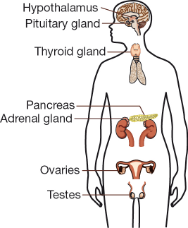
1

2 The chemical messengers of the endocrine system are known as hormones. They are produced in endocrine glands. Hormones move in the blood stream to reach every cell in the body. However, not every cell responds to the message. Only cells with specific receptors react. They are target cells.
3 Compare the nervous and endocrine systems by completing the table.
Nervous system | Endocrine system
Messages travel along nerves | Messages travel in the blood stream
Messages are in the form of nerve impulses. | Messages are in the form of chemicals (hormones).
Messages travel in one direction. | Messages travel throughout the body but only act on target cells.
Messages cause very fast reactions. | Messages cause slow changes.
Controls things like:  heart beat, breathing, movement | Controls things like:  changes of puberty, growth

For other classes, answers for activity book work are in the teacher’s manuals on a shelf in the prep room (I think the year 8 one is on my desk)

